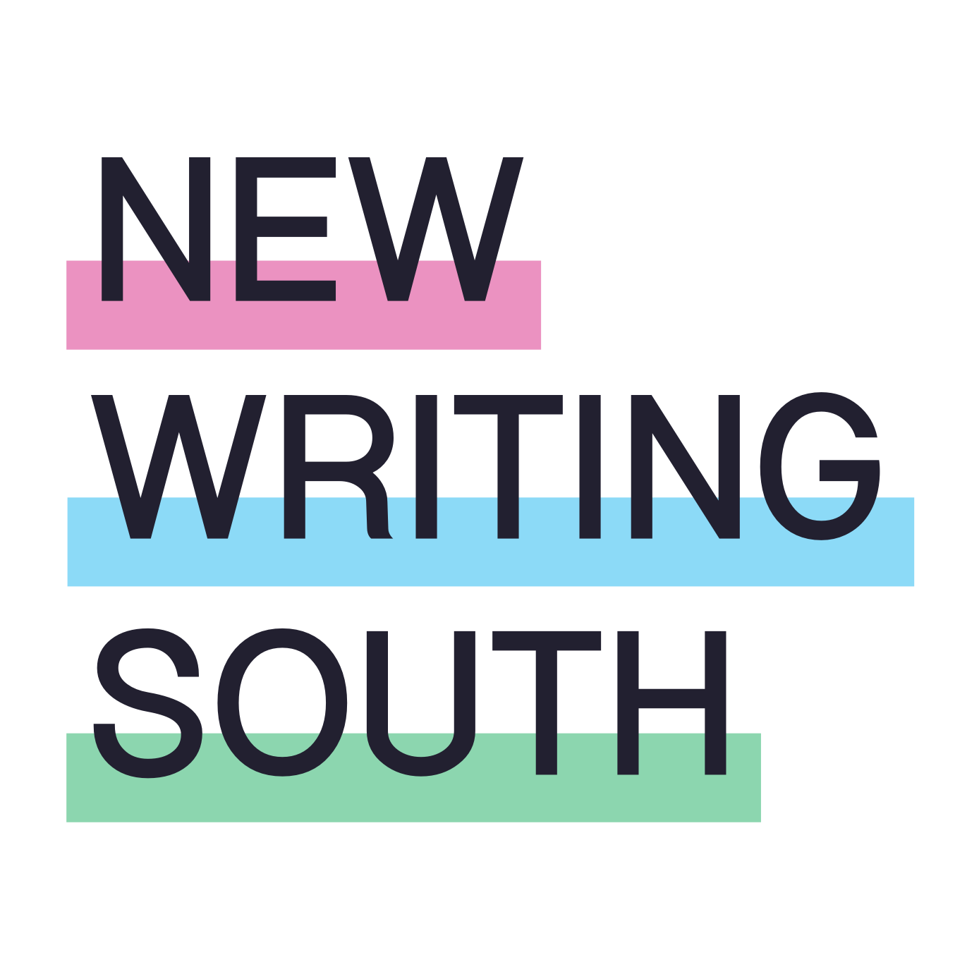

TRUSTEE RECRUITMENT PACK

Welcome to New Writing South where we strive to drive opportunity for diverse writers in South East England. Supporting a vibrant writing community across the region, helping develop the careers of gifted writers of colour, amplifying working class voices in literature, bringing our best LGBTQ+ writing to an international stage – these are actions that we passionately believe will help writers write the books we want (and deserve!) to read.

We are seeking new Trustees, with new ideas and new ambition, to help us make a real mark on the UK creative writing sector. If you share our passion and are interested in helping to make these changes, we would love to hear from you. We welcome candidates with all kinds of personal and professional life experience, and genuinely believe that being a New Writing South Trustee will make that experience even richer.
Lesley Wood, CEO

ABOUT NEW WRITING SOUTH
New Writing South is an Arts Council England National Portfolio Organisation (NPO). We have recently been awarded three-year funding from 2023-26 to deliver our mission to support, inspire, encourage and share the best, most diverse, most thrilling writing in the South East of England.

We strive to support the careers of writers who still, a quarter of the way through the 21st century, find it difficult to get their books on shelves. From our fabulous queer literature festival - the only one of its kind in the UK - to residencies for writers of colour in the astonishing architecture of West Dean College, with masterclasses, courses, writing groups, community projects and much more in between, we champion underrepresented writers and help them be the best they can be. We are ambitious for our writers and passionate about bringing their work to adventurous readers.

As we move into a renewed 3-year funding period from Arts Council England, New Writing South is seeking three new Trustees to sit on our Board and help us grow our vision
- to make The Coast is Queer literature festival truly international
- to create safe and welcoming accessible space(s) where all writers, but especially writers from Black, Asian and global majority backgrounds, can thrive
- to promote and bring working class voices to the fore, and
- to motivate readers to seek out and be rewarded by excellent, diverse writing.

THE TRUSTEES WE ARE LOOKING FOR
We are looking for people who genuinely understand and champion diversity, who are ambitious and will bring fresh thinking to New Writing South to help us push boundaries and grow.

We are not necessarily looking of people with previous Trustee experience – we want people from all sorts of life experience and will provide full and appropriate training and induction for all new Trustees. Nor are we looking for Trustees to be involved at a day-to-day operational level – we don’t need anyone to tell us to send more tweets on a Tuesday.

We do need new Trustees who will help us shape the big decisions, set strategy, develop the locations and the writers and audiences we engage with. And, of course, Trustees who share our passion for writing and believe in the contribution it can make to an open, diverse society.

Knowledge and expertise
We welcome applications from within or outside the arts sector, including people with community-based, financial or marketing experience. We would like, for example, to meet applicants who are keen to help us better understand and advocate for the impact of our work and the place of writer development within the wider arts sector. We would love to market our organisation and our work, and tell our own story, better. We value connections with the publishing and higher education sectors and are keen to be more innovative and braver in how we use digital technologies.

We would welcome connections with money and finance – whether that’s expertise around financial planning, grant funding, donations and giving, or more entrepreneurial approaches to earning income. And we are always looking to expand our networks with local communities especially in the Crawley and Eastbourne areas. Can you help with any of these?

We will also be measuring our work against Arts Council England’s Investment Principles and all Trustees will be given training to help oversee that objective.

We are clear that to drive our ambitions forward with vision and confidence New Writing South must have a diversity of voices at every level within the organisation. We value lived experience in all its forms and encourage applications from everyone irrespective of perceived ability, age or gender. People from the global majority, who are LGBTQ+, disabled and/or from working class or low socio-economic backgrounds are particularly encouraged to apply. See our full Shortlisting Statement* below.

Our current Trustees
We currently have four Trustees: Petal Felix, Katy Massey, David Sheppeard and Vedrana Velikovic.

- Petal is a freelance journalist, radio and television producer. She is interested in books by Black writers.
- Katy is a writer and creative writing tutor. Her first book was shortlisted for the Jhalak Prize. She is currently working on her first fiction novel.
- David is the Executive Director of Marlborough Productions, Brighton’s producer of queer art and culture. He continues to develop his own artistic work as a writer and performer.
- Vedrana is Principal Lecturer in English Literature at the University of Brighton. She is co-founder of the student-staff DeCol Collective and is interested in Black British and post-Yugoslav women writers, BrexLit and post-communism.

THE ROLE OF THE BOARD
The current Board of dedicated individuals bring a wide range of skills and experience from the creative, cultural and education sectors. Under the steer of Interim Chair, David Sheppeard, Board members volunteer their time to guide the organisation strategically, meeting quarterly either in Brighton or virtually. Papers including financial statements, activities round-ups, policy documents and project proposals are circulated in advance for the Board to discuss, question and feedback on at meetings. Everyone is invited to email in advance of meetings if anything in the Board papers is not clear. Trustees use their expertise to work with the CEO on sub-committees or to help prepare papers or proposals. These are voluntary positions, but reasonable out-of-pocket expenses are paid.

The role of the Board is:

- to be accountable for the strategic direction of NWS
- to protect the financial stability of the organisation
- to have oversight of delivery against Arts Council England’s Lets Create strategy’s Outcomes and Investment Principles
- to ensure compliance with governance legislation and strive for best practice to safeguard the reputation and values of the NWS
- to guide and test the decision-making of the executive leadership including:
- vision, mission, aims, objectives
- impact and legacies
- business planning including fundraising
- financial projections and accounts
- partnership development
- legal matters

In addition, the Board also:
- contributes to fundraising both actively and in an advisory capacity
- supports the CEO and her team in developing and producing the best possible outcomes for our beneficiaries and stakeholders, particularly by contributing professional expertise, insight and connections
- contributes to the development of longer-term plans and projections, to better articulate our goals for the future while building a sustainable and thriving enterprise, more capable of projecting and therefore mitigating risk.

We realise that not everyone will have experience of every aspect of the Trustee role. Full training and briefings will be given and additional support provided as necessary to support new Trustees and enable full team working across the Board.

TIME COMMITMENT
We hold four Board meetings a year and one Away Day where there is food and thinking time and a chance to look further ahead to develop our strategic thinking. Trustees are expected to attend Board development activities including training. Subcommittees work with the CEO and staff team between meetings so altogether we estimate Trustees will devote up to 4-6 days of time per year.

All Trustees must be UK-based and will be expected to physically attend a minimum of two out of four quarterly meetings. Meetings last two hours with the exception of the annual half- or full-day Away Day. There will be additional ‘special events’, such as The Coast is Queer festival, fundraisers and/or other events, to which Trustees are invited but not obliged to attend. These events offer the opportunity to really understand the work we do and get to know the staff team, alongside the writers and readers we work with.

The post is for a minimum of three years (one term) starting in Spring 2023 and most Trustees serve two terms, or a maximum of six years.

EXPENSES
In compliance with charity law this is an unpaid voluntary position. Reasonable expenses may be claimed including travel costs, access support costs and child care costs for attending Board and other meetings.

BENEFITS OF BEING A NEW WRITING SOUTH TRUSTEE

Contributing to a cause that you believe in
We believe that arts, and literature in particular, are more important now than ever. Storytellers, poets and lyricists will be critical in shaping a bolder, braver, more equitable future. As an NWS Trustee, you will play a powerful role in working toward that future.

Professional development through strategic experience
Being a Trustee is a fantastic way to develop and hone the critical thinking, problem-solving and analytical skills needed for strategic oversight. Communication and people-skills including negotiating, empathising, listening and clearly communicating ideas and concerns are essential to positive, forward-thinking and efficient charity governance. Access to training supplied by NWS can also build confidence in your leadership role as a Trustee.

Building networks
Meeting people from diverse personal and professional backgrounds while working toward a common cause can open up professional and social networks, uncover career opportunities and create lifelong friendships. As a member of NWS Board of Trustees you will be joining a passionate group of writers, lecturers, business leaders and activists from diverse backgrounds and varied life experience.

Making New Writing South stronger and giving back to the community
Our Trustees help ensure the viability and sustainability of our organisation and contribute to achieving our mission, bringing benefits to the writing community and their readers in the South East. We could not do without them.

INTERESTED?
If you share our passion for writing and the contribution it can make to an open, diverse society and you think you would enjoy the challenge of helping us to build a stronger, inclusive, sustainable organisation, we would love to hear from you.

To apply for this role, please send us a letter (no longer than one side of A4), a 4-minute video (MP3/MP4 video files) or voice memo (audio file) – whatever you are comfortable with. Tell us what you might bring to the Board, what motivates you, why you think championing the values and aims of our organisation is an exciting prospect, and any personal qualities, passions and ideas that you would bring as a Trustee of New Writing South. You are welcome to send your CV.

If you have any other access requirements in order to apply, please contact liam@newwritingsouth.com

Please send your application to lesley@newwritingsouth.com with ‘Trustee Application’ as the subject by 5pm on Wednesday 15th February 2023

Please also complete and return the Equal Opportunities form below. This information will be treated as confidential and used for shortlisting and statistical purposes only (see Shortlisting Statement below). You can find our Data Protection Policy here.

Interviews will be held in the week beginning 20th February 2023 and will be carried out virtually using online platforms.

We are also recruiting for a new Chair of Trustees. You can find information about this role here.

SHORTLISTING STATEMENT*
People from certain groups are still currently under-represented in the arts nationwide, and we are committed to challenging and changing this.

People from the global majority, who are LGBTQIA+, disabled and/or from working class or low socio-economic backgrounds are particularly encouraged to apply for the role of Trustee.

The category of people in the global majority includes, but is not limited to, people of Black Caribbean, Black African, South Asian, East Asian, South East Asian, West Asian, Arab, Latinx, Jewish, Romany and Irish Traveller heritage.

The category of disabled people includes, but is not limited to, those who define as disabled people, as people with long term health conditions, as deaf, Deaf, neurodivergent or in relation to their health-related access requirements.

New Writing South does not anonymise applications and we reference equalities data for balancing our shortlist, as one of our scorable criteria is to add to the diversity of our Board.

This means when we shortlist, we always interview the highest scoring applicants and may also consider adding in few lower scoring candidates. This is because we understand that meeting repeated barriers might impact on the experience and employment opportunities people have been able to gather to date.
* Thanks to Unlimited for advice and wording for the shortlisting process

New Writing South Equality and Diversity Form
New Writing South is committed to equality and diversity in its broadest sense. The information collected below is for diversity monitoring records only.
Post code
…………………………………………………………………….
Please tell us which age bracket you are in.
- 0-19
- 20-34
- 35-49
- 50-64
- 65-74
- 75+
- Prefer not to say
Your gender?
- Female (including trans women)
- Male (including trans men)
- Non-binary
- Prefer not to say
- Other
If you selected other for the above question, please specify
…………………………………………………………………….
What is your sexual orientation?
- Queer
- Gay Man
- Gay Woman/ Lesbian
- Heterosexual
- Bisexual
- Prefer not to say
- Other
If you selected other for the above question, please specify
…………………………………………………………………….

What is your ethnic identity? Please only select one answer
○ White British ○ Bangladeshi
○ White Irish ○ Chinese
○ White Gypsy or Traveller ○ Any other Asian background
○ Any other White background ○ Black Caribbean
○ White & Black Caribbean ○ Black African
○ White & Black African ○ Any other Black background
○ White & Asian ○ Arab
○ Any other mixed background ○ Latin American
○ Indian ○ Any other ethnic group
○ Pakistani ○ Prefer not to say

Do you consider yourself to be disabled according to the Equality Act 2010 definition – that is, you have a physical or mental impairment that has a ‘substantial’ and ‘long-term’ negative effect on your ability to do normal daily activities?
○ Yes
○ No
○ Prefer not to say

Are you neurodivergent?
○ Yes

○ No

○ Prefer not to say

