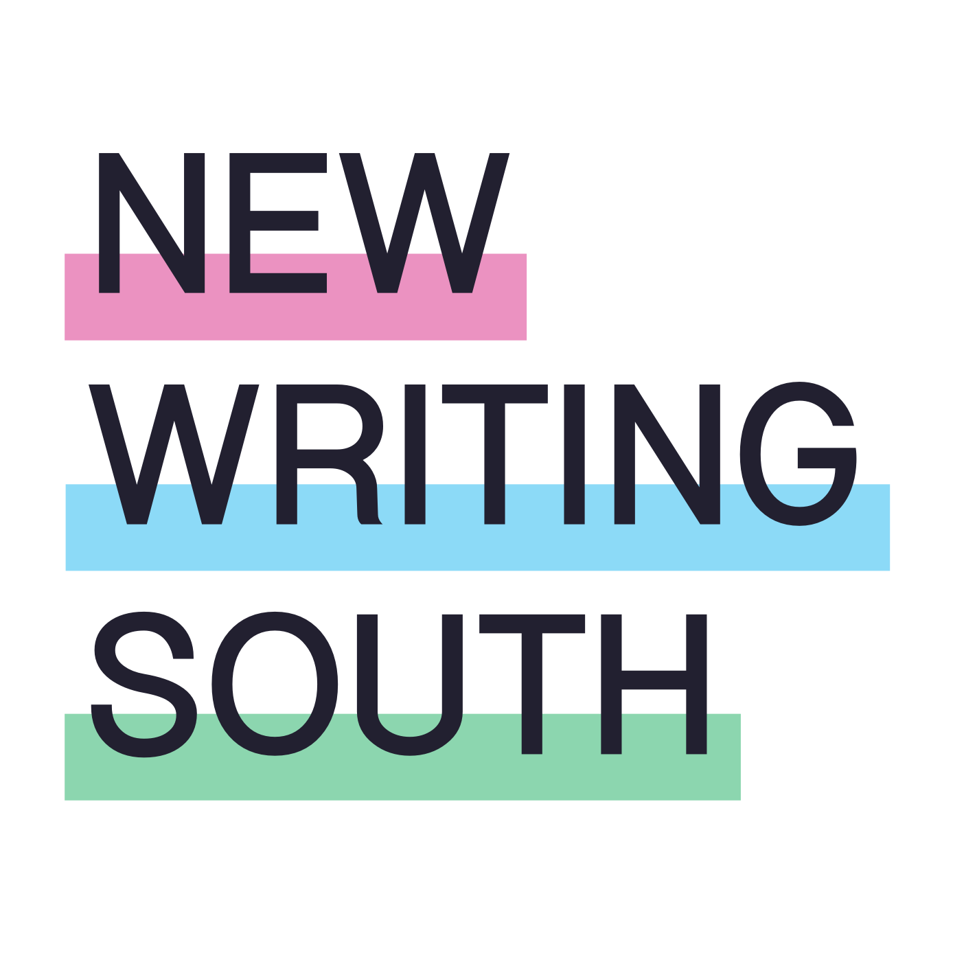

CHAIR OF TRUSTEES RECRUITMENT PACK

Welcome to New Writing South where we strive to drive opportunity for diverse writers in South East England. Supporting a vibrant writing community across the region, helping develop the careers of gifted writers of colour, amplifying working class voices in literature, bringing our best LGBTQ+ writing to an international stage – these are actions that we passionately believe will help writers write the books we want (and deserve!) to read.

We are very pleased to be recruiting a new Chair to lead the Board at such a buoyant moment in our history. Despite the undeniable challenges of the 2020s, we are elated to have secured core funding from Arts Council England for another three years – funding that will support brilliant writing across the region and create the opportunity for our fabulous LGBTQ+ literature festival, The Coast is Queer, to flourish and grow. It is an exciting time to join NWS and we’re looking forward to the leadership and ambition a new Chair will breathe into the organisation.
Lesley Wood, CEO

ABOUT NEW WRITING SOUTH
New Writing South is an Arts Council England National Portfolio Organisation (NPO). We have recently been awarded three-year funding from 2023-26 to deliver our mission to support, inspire, encourage and share the best, most diverse, most thrilling writing in the South East of England.

We strive to support the careers of writers who still, a quarter of the way through the 21st century, find it difficult to get their books on shelves. From our fabulous queer literature festival - the only one of its kind in the UK - to residencies for writers of colour in the astonishing architecture of West Dean College, with masterclasses, courses, writing groups, community projects and much more in between, we help underrepresented writers be the best they can be and champion their work. We are ambitious for our writers and passionate about bringing their work to adventurous readers.

Specifically over the next three years, we aspire to:
- make The Coast is Queer literature festival truly international
- create safe and welcoming accessible space(s) where all writers, but especially writers from Black, Asian and global majority backgrounds, can thrive
- promote and bring working class voices to the fore, and
- motivate readers to seek out and be rewarded by excellent, diverse writing from the South East.

The Chair we are seeking
As we move into the 3-year NPO funding period, we are seeking a new Chair who can help make our vision of an equitable future, where everyone is empowered to write and enjoy writing in all its forms, a reality. We are looking for a Chair who is ambitious and will build on our successes, bringing fresh thinking to push boundaries and further strengthen our small but dynamic organisation.

We are looking for a team approach at Board level so the Chair will lead our Board to work in ways that are genuinely inclusive. Our new Chair will be an influential, supportive leader who builds confidence and consensus.

If this is you, you will join a welcoming, committed and skilled group of Trustees who champion and advocate for our work locally and regionally, sharing our passion for writing and the contribution it can make to an open, diverse society.

I have really enjoyed being Chair of New Writing South, facing the various challenges and triumphs of the past 5 years. The quality of work the organisation does with communities is reflected in the success, both of its supported writers and the niche but mighty festival, The Coast is Queer. New Writing South is poised to go from strength to strength and it will be an exciting time to be Chair. Rob Warr, Chair 2018-2022

ROLE PROFILE and PERSON SPECIFICATION

The role of Chair is a voluntary (unpaid) role, responsible for leading the Board of Trustees of New Writing South, ensuring it fulfils its responsibilities for governance of the organisation.

The Chair works with the CEO helping her achieve the strategic aims of the organisation, deliver the agreed vision, mission, and strategic objectives and optimise the relationship between the Board of Trustees and the staff.

We are clear that to drive our ambitions forward with vision and confidence we must have a diversity of voices at every level within the organisation. We value lived experience in all its forms and encourage applications from everyone irrespective of age or gender. People from the global majority, who are LGBTQIA+, disabled and/or from working class or low socio-economic backgrounds are particularly encouraged to apply. See our full Shortlisting Statement* below.

KEY RESPONSIBILITIES

The main responsibilities of the Chair are:
- To provide leadership for the Board of Trustees
- To ensure New Writing South remains focused on its charitable aims
- To maintain a strategic overview of the organisation’s affairs including delivery of the business plan, supporting the CEO as appropriate
- Oversight of the Arts Council England’s National Portfolio funding agreement including delivery, monitoring and reporting against the Let’s Create strategy’s Outcomes and Investment Principles
- To ensure compliance with governance requirements
- To maintain oversight of how Trustees help to deliver fundraising objectives
- To authorise action to be taken between meetings of the full Board when necessary
- To represent the organisation at key events and meetings, acting as an ambassador and a spokesperson
- To set the agenda for Board meetings in collaboration with the CEO
- To chair Board meetings, promoting effective decision making and constructive debate and to oversee the implementation of decisions taken
- To direct Trustee recruitment and oversee succession planning
- To contribute to appointment panels for senior staff and Trustees as required
- To collaborate with the CEO in setting and reviewing performance objectives
- To authorise payments over £5,000

PERSON SPECIFICATION

Essential
- Strong leadership skills
- A strong commitment to the core values of New Writing South
- Proven track record of thinking and acting strategically
- Demonstrable commitment to equality, diversity and inclusion and willingness to take action to ensure the organisation is representative, from the top down
- An understanding of Arts Council England’s Let’s Create strategy
- Comfortable in the role of advocate, bringing influence, knowledge and credibility to the role and using tact and diplomacy including with reference to fundraising
- Experience of charity governance
- Good 'people' skills
- Proven ability to act impartially and with fairness while respecting confidences
- Capacity to devote sufficient time to fulfil the role effectively
- Knowledge of the South East region

Desirable
- An interest in creative writing
- Interested in a challenge, and change management
- curiosity beyond your expertise
- Senior management experience within an arts and culture, third sector or public sector organisation
- Engagement with cultural and business networks in Brighton & Hove and the South East

BENEFITS OF BEING THE CHAIR OF A CHARITY*

Contributing to a great cause
Being the Chair of a charity is arguably one of the most powerful ways in which you can contribute to your local community or to a cause you really care about. As a Chair, you play an integral part in the good governance of a charity, not only ensuring that the organisation remains viable and sustainable but ensuring that it adheres closely to its mission and works in the interests of its beneficiaries.

Enhanced strategic experience
As a Chair, you are likely to already have experience as a Trustee. The strategic oversight required of the Chair gives you the opportunity to develop and hone your critical thinking, problem-solving and analytical skills as well as developing vital strategic sensibilities and team working skills. It allows for big picture thinking and an understanding of a new sector/set of networks.

Development of People Skills
The role of Chair can develop your ability to collaborate effectively with others, to constructively challenge the ideas of fellow Trustees as well as those of the Executive Director, Artistic Director and staff. Negotiating, empathising, listening and clearly communicating ideas and concerns are huge factors in this process and often help to set the tone and culture of Board meetings. All of this is essential to positive, forward-thinking, and efficient charity governance, but it’s also a fantastic opportunity to develop sound judgement and interpersonal skills.

Personal Development
Being a Chair is challenging. There is a high level of responsibility and a considerable time commitment. In return, you will gain a wealth of personal and professional skills and connections which will stand you in good stead whilst empowering you with a new sense of purpose and prospect.

TIME COMMITMENT

The time commitment is approximately 12 days a year and includes:
- Quarterly Board meetings and a meeting with the CEO beforehand to discuss the agenda
- Board events including an annual Away Day and Board development including training
- Important New Writing South events including key festival events, launches, and fundraising events
- Attending other key meetings and events as required
- The Chair may be invited to attend subcommittee meetings

The Chair will be appointed for a minimum term of three years starting in Spring 2023, taking over from Interim Chair, David Sheppeard. They can be re-elected for a second three-year term but must stand down at the end of the second term.
EXPENSES
In compliance with charity law this is an unpaid voluntary position. Reasonable expenses may be claimed including travel costs, access support costs and child care costs for attending Board and other meetings.

HOW TO APPLY

If you are interested in applying for the role of Chair, there are three ways to apply.
Please write us a letter up to two pages via email, an 8-minute video (MP3/MP4 video file) or voice memo (audio file) via WeTransfer – whatever you are comfortable with. Or, if you have any other access requirements in order to apply, please contact liam@newwritingsouth.com
Please outline the specific skills, knowledge and experience you have that are relevant to the role, with reference to the person specification. We are also interested to learn what motivates you, why you think championing the values and aims of our organisation is an exciting prospect and any personal qualities, passions and ideas that you would bring as Chair of New Writing South.
Please send your application with your CV and availability to attend an online interview online by
5pm Wednesday 15th February.
Interviews will take place in the fortnight beginning 20th February.

Send your application to lesley@newwritingsouth.com with ‘Chair Application’ as the subject
Please also complete and return the Equal Opportunities form below. This information will be treated as confidential and used for shortlisting and statistical purposes only (see Shortlisting Statement below). You can find our Data Protection Policy here.
We are also recruiting for three new Trustees. You can find information about these roles here.
SHORTLISTING STATEMENT*

People from certain groups are still currently under-represented in the arts nationwide, especially in leadership roles. New Writing South is committed to challenging and changing this.

People from the global majority, who are LGBTQIA+, disabled and/or from working class or low socio-economic backgrounds are particularly encouraged to apply for the role of Trustee.

The category of people in the global majority includes, but is not limited to, people of Black Caribbean, Black African, South Asian, East Asian, South East Asian, West Asian, Arab, Latinx, Jewish, Romany and Irish Traveller heritage.

The category of disabled people includes, but is not limited to, those who define as disabled people, as people with long term health conditions, as deaf, Deaf, neurodivergent or in relation to their health-related access requirements.

New Writing South does not anonymise applications and we reference equalities data for balancing our shortlist, as one of our scorable criteria is to add to the diversity of our team.

This means when we shortlist, we always interview the highest scoring applicants and may also consider adding in few lower scoring candidates. This is because we understand that meeting repeated barriers might impact on the experience and employment opportunities people have been able to gather to date.

New Writing South Equality and Diversity Form
New Writing South is committed to equality and diversity in its broadest sense. The information collected below is for diversity monitoring records only.

Post code
…………………………………………………………………….
Please tell us which age bracket you are in.
- 0-19
- 20-34
- 35-49
- 50-64
- 65-74
- 75+
- Prefer not to say
Your gender?
- Female (including trans women)
- Male (including trans men)
- Non-binary
- Prefer not to say
- Other
If you selected other for the above question, please specify
…………………………………………………………………….
What is your sexual orientation?
- Queer
- Gay Man
- Gay Woman/ Lesbian
- Heterosexual
- Bisexual
- Prefer not to say
- Other
If you selected other for the above question, please specify
…………………………………………………………………….

What is your ethnic identity? Please only select one answer
○ White British ○ Bangladeshi
○ White Irish ○ Chinese
○ White Gypsy or Traveller ○ Any other Asian background
○ Any other White background ○ Black Caribbean
○ White & Black Caribbean ○ Black African
○ White & Black African ○ Any other Black background
○ White & Asian ○ Arab
○ Any other mixed background ○ Latin American
○ Indian ○ Any other ethnic group
○ Pakistani ○ Prefer not to say

Do you consider yourself to be disabled according to the Equality Act 2010 definition – that is, you have a physical or mental impairment that has a ‘substantial’ and ‘long-term’ negative effect on your ability to do normal daily activities?
○ Yes
○ No
○ Prefer not to say

Are you neurodivergent?
○ Yes

○ No

○ Prefer not to say

